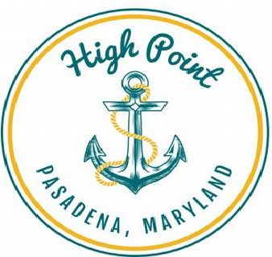
High Point Improvement Association
2023-2024 Membership Application
P. O. Box 1004, Pasadena, MD 21122
E-Mail: HighPointAssn@gmail.com
Name of resident:
Address:
e-Mail:
Phone:
Note: If you provide an e-mail address, you will receive occasional e-mail updates from the Association. You may opt out of theses updates at any time.
I am a High Point resident living at the above address. I understand my membership allows me to vote on issues that come before the High Point Improvement Association, Inc. through the periods for which dues are paid as shown below. If I decide to purchase a Boat Ram Key after becoming a member, my current dues will be applied to the cost of the key. A separate Boat Ram Key Application will need to be submitted to receive a Ramp Key.
Member Signature: ________________________________________________ Date: ____________________
- One year membership good through March 14, 2024 @ $10 _________________
- Two year membership good through March 13, 2025 @ $20 _________________
- An additional donation to the Association _________________
Total amount submitted: _________________

I would like to volunteer for:
◻ Committee Member ◻ Beach/Ramp Clean-up ◻ Block Party

Membership Question
The HPIA Charter limits our activities to holding neighborhood events and taking action to improve our community and maintaining our community property, which is the High Point community beach, pier, and boat launching ramp. Within those limits, what is the one issue most important to you that your Community Association needs to address?
______________________________________________________________________________________________________________________________________________________________________________________________________________________________________________________________________________________________________

